**Technical Assesment Devops**

1. **How to use CI/CD Web with Jenkins**

* **Check status before deployment**
* First check status deployment web application on environment staging and production

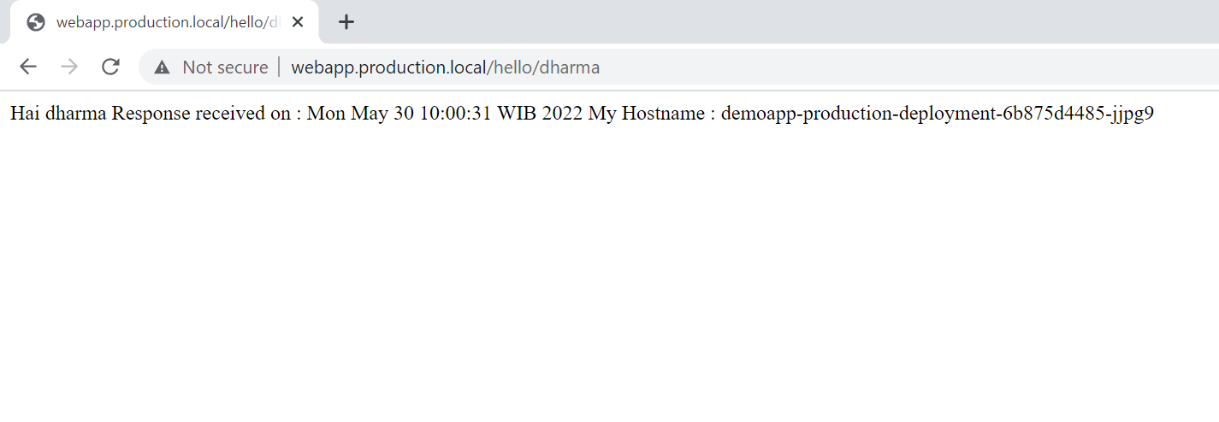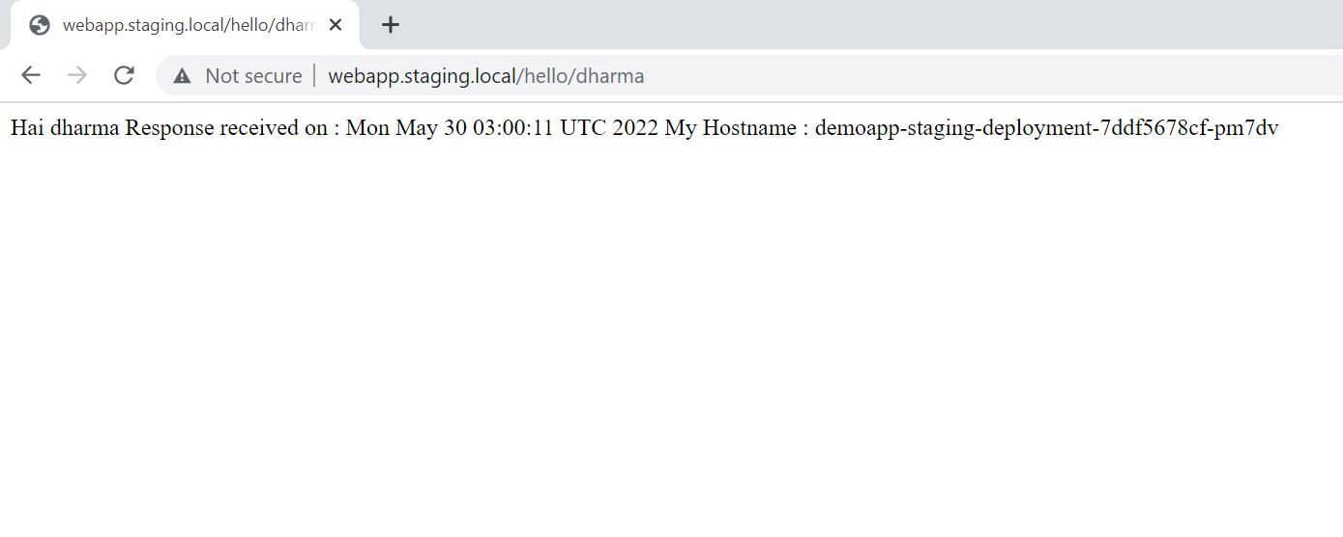

* Check all service on Kubernetes cluster and check version image deployment file

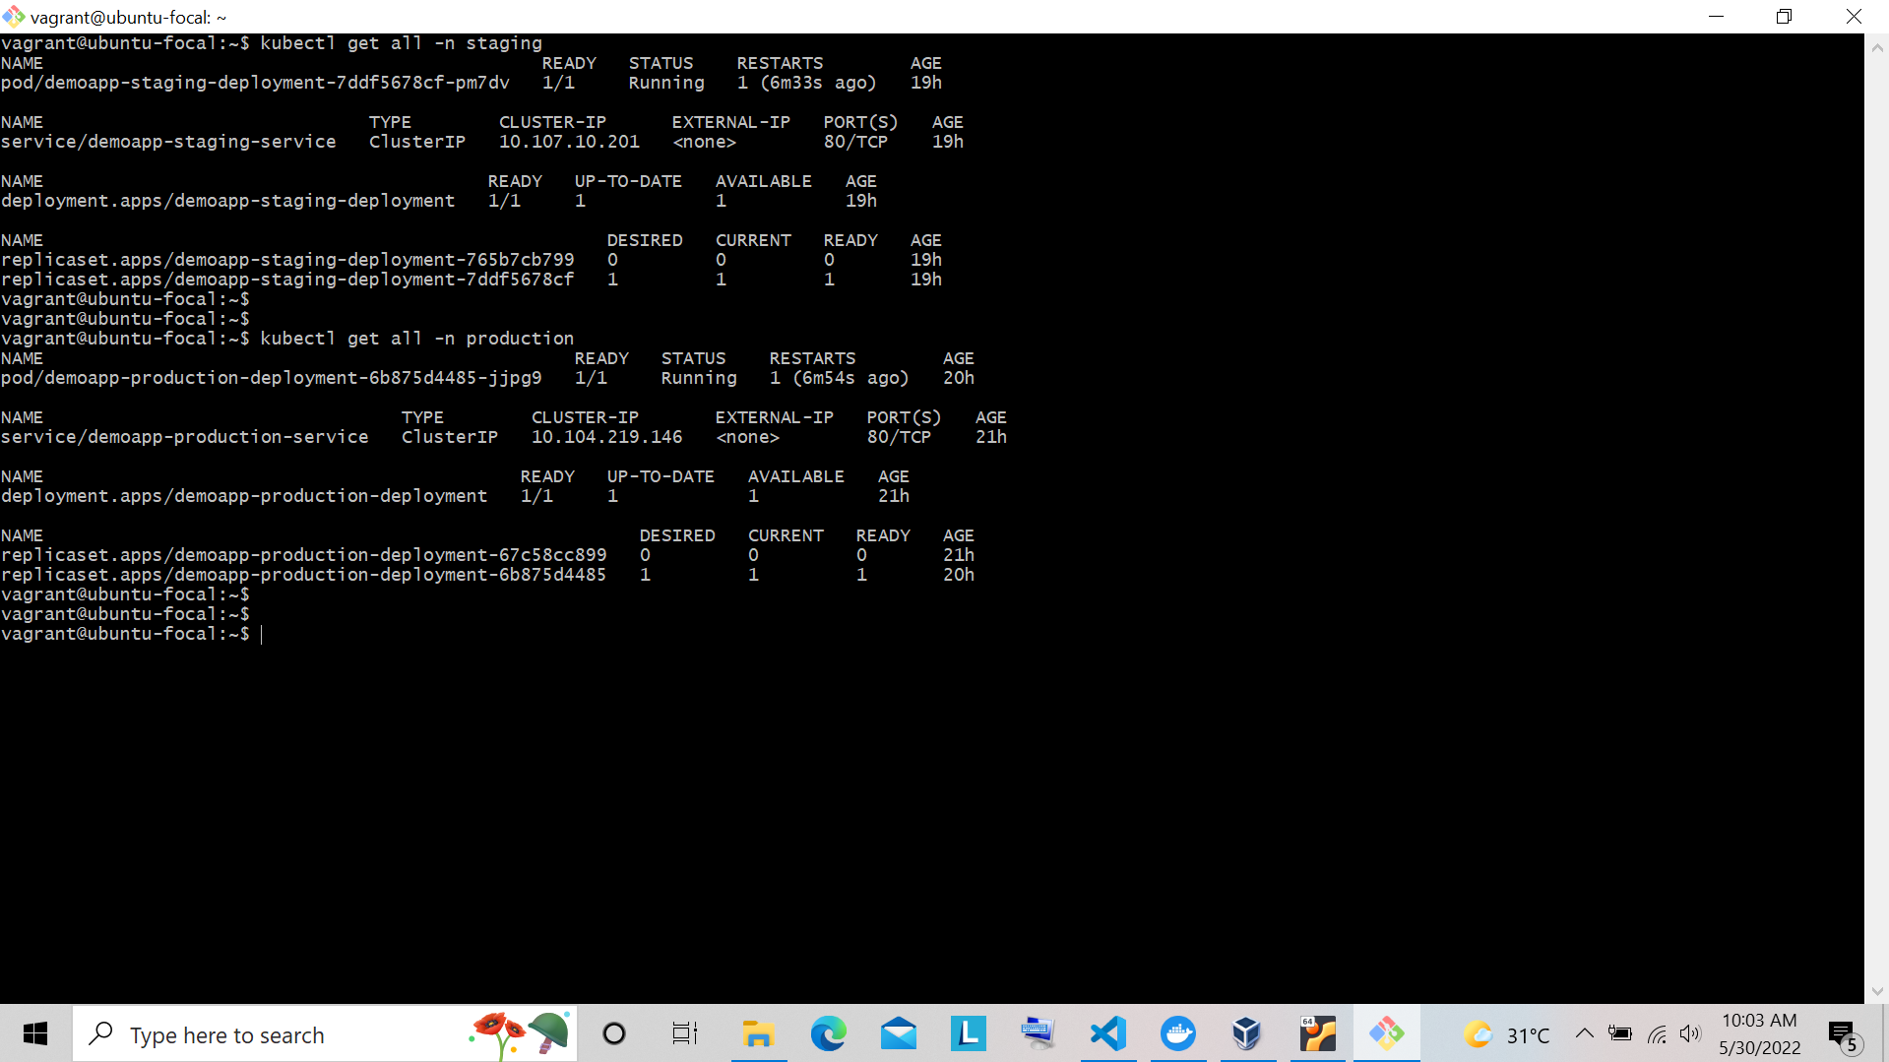

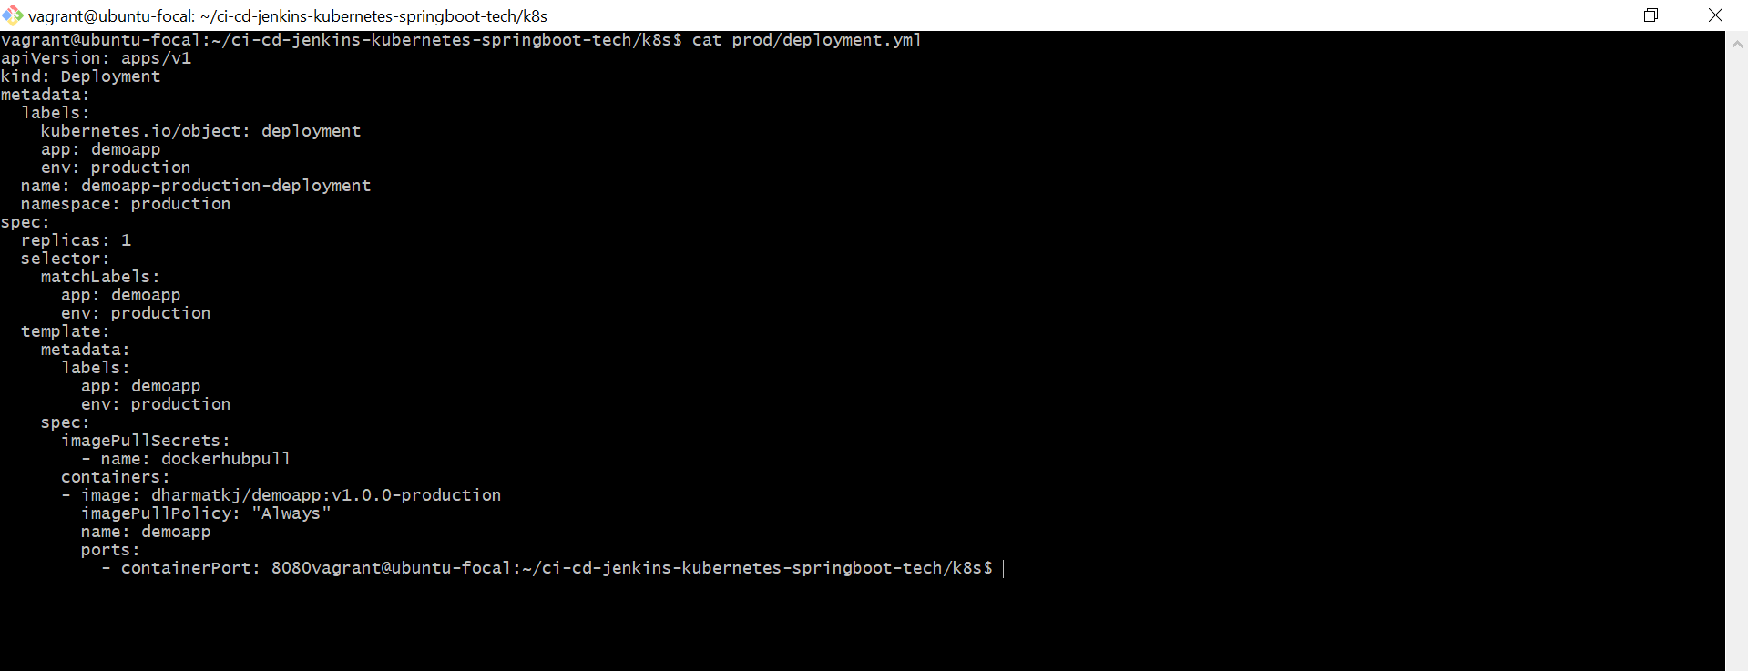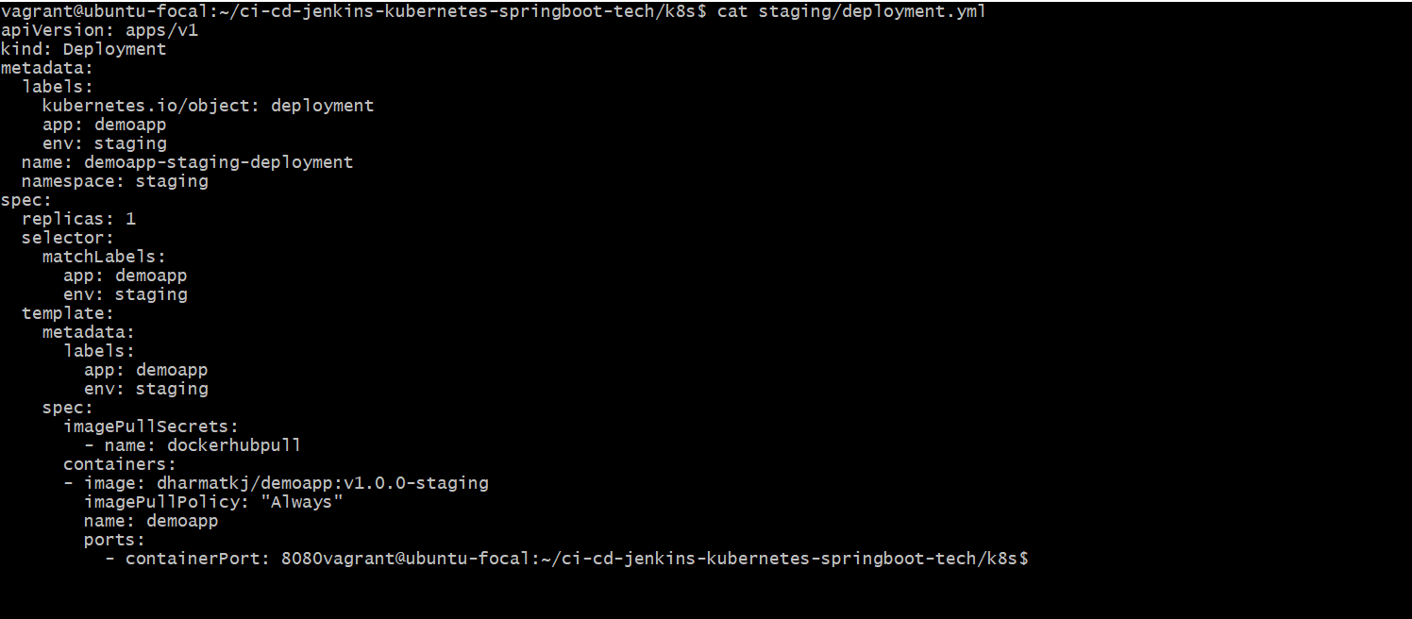

* **Developer create branch to update feature**
* Create new branch for develop application for example name branch **fix/fixing-endpoint-response**.
* Update code for fixing application with your code editor.

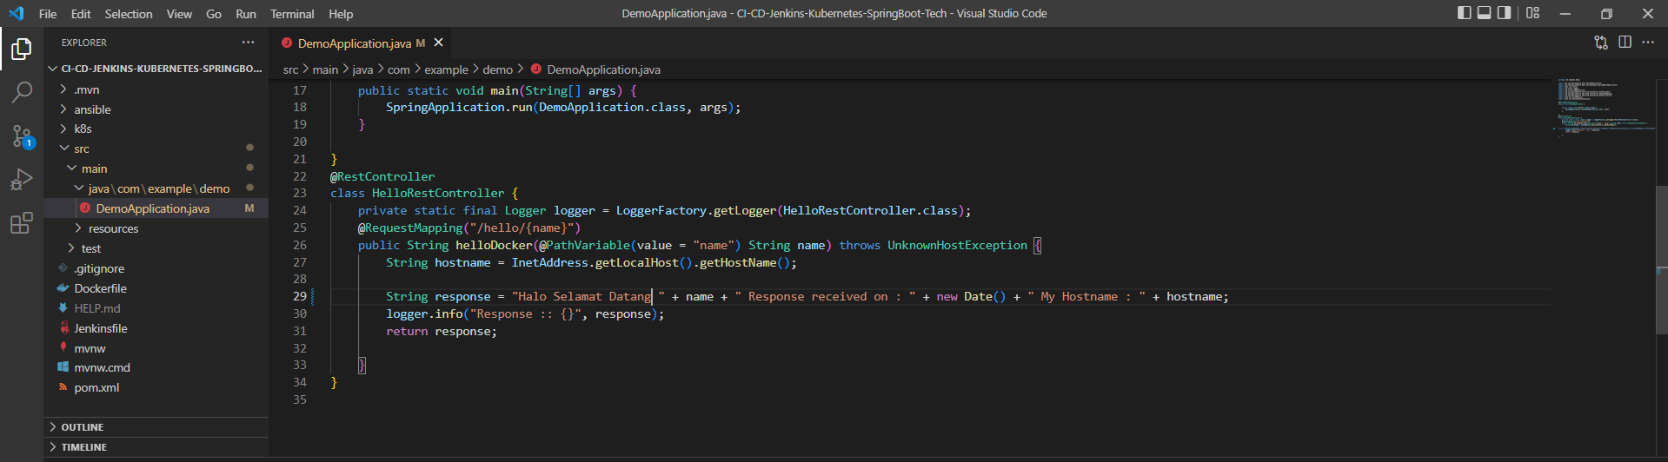

* Push branch to repository.

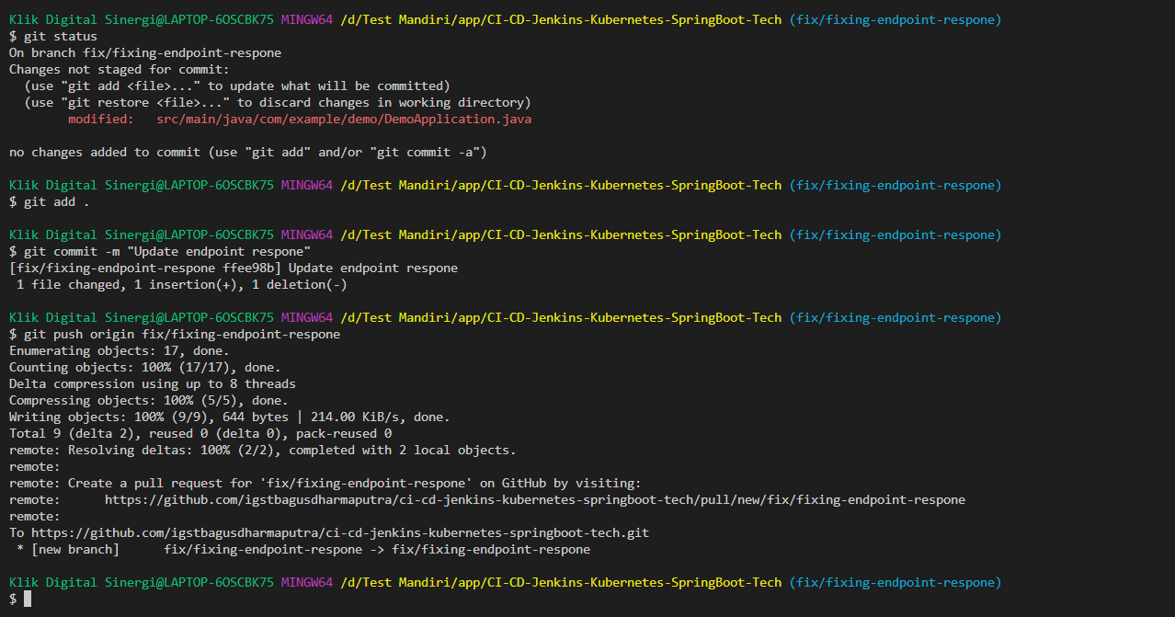

* Create pull request to merge from new source code fixing to branch environment **staging**

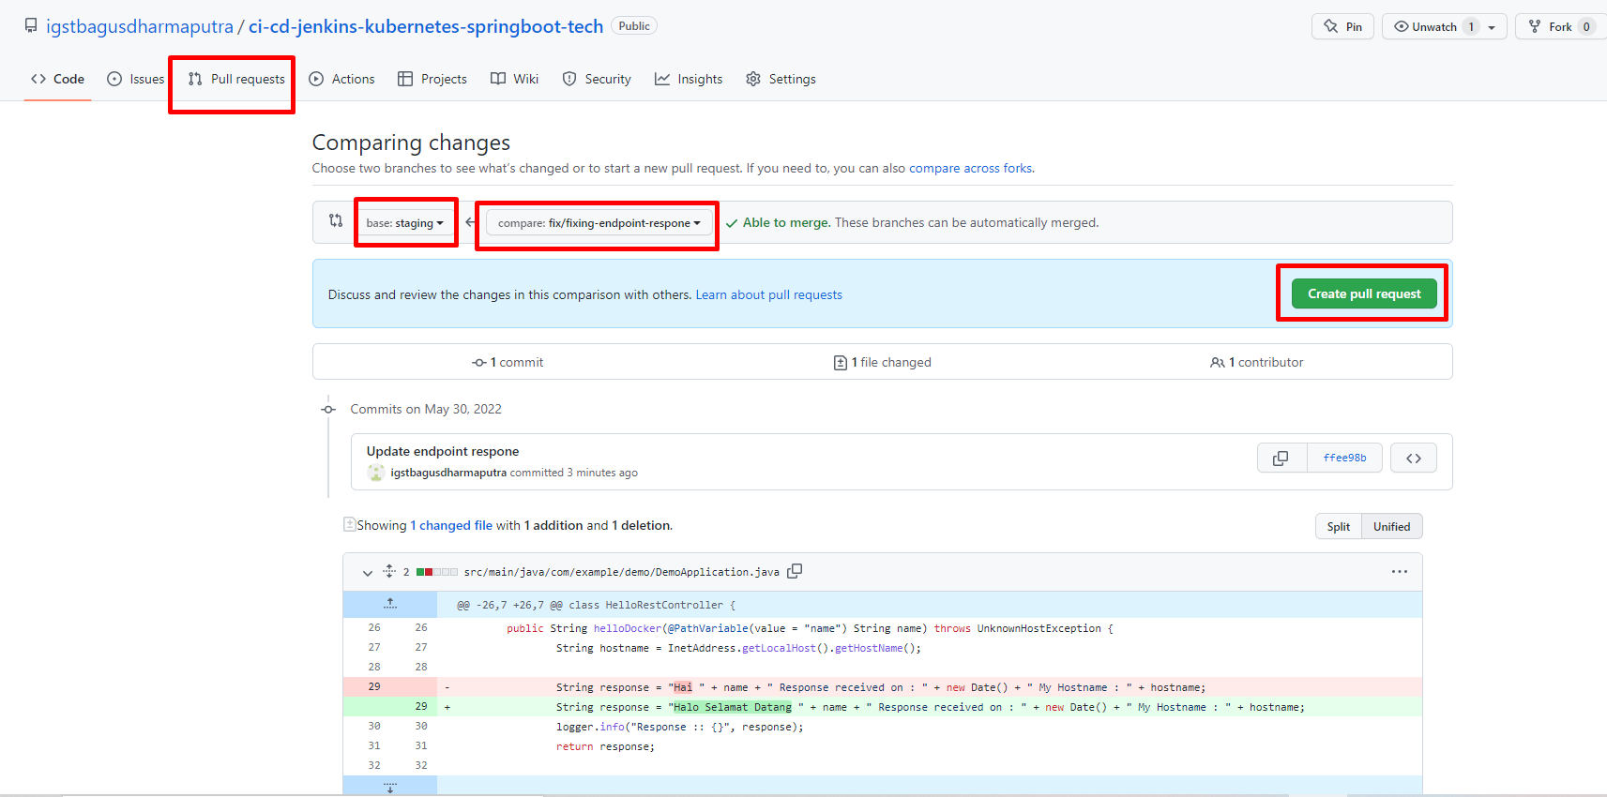

* Approve pull request for the next step.

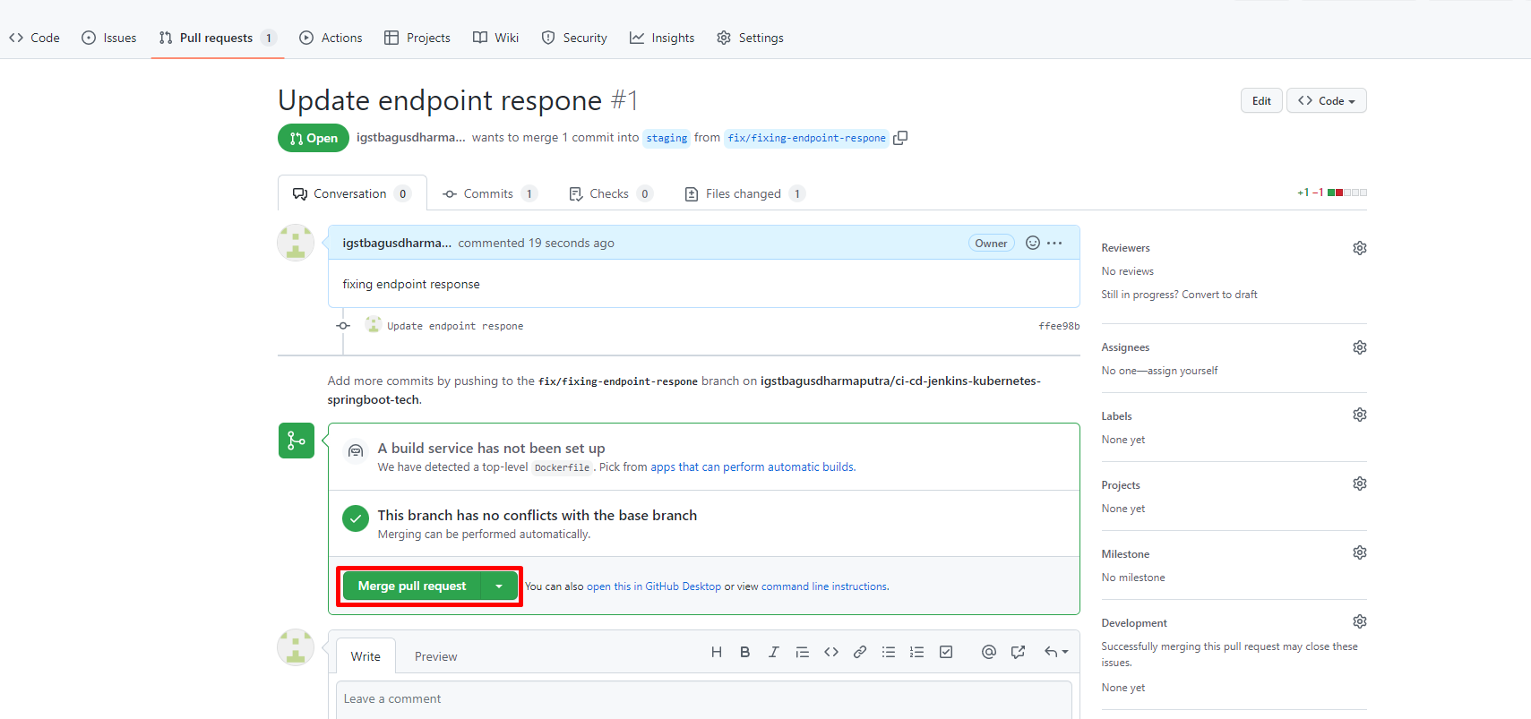

* Check changes source on branch staging.

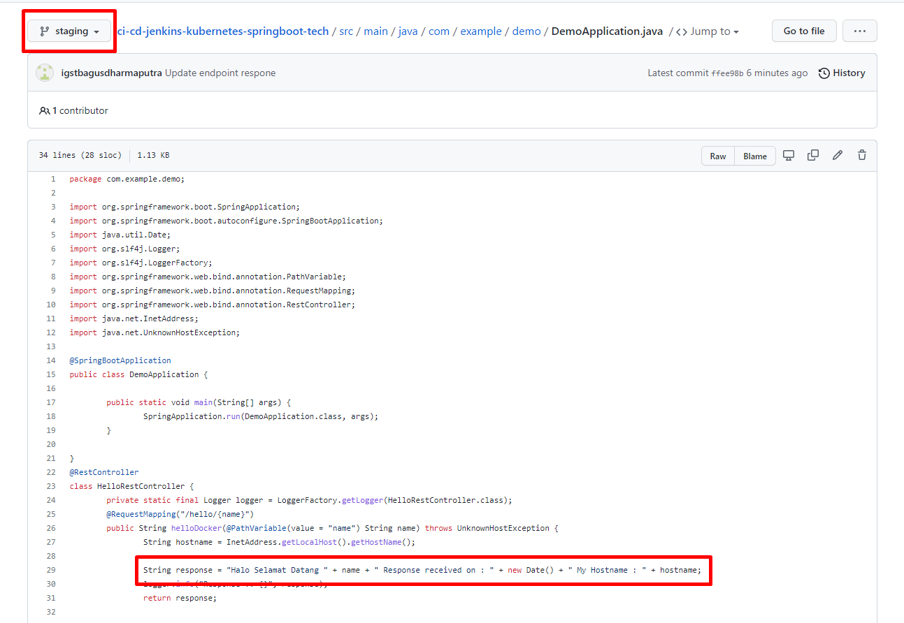

* **Run Jenkins to Deploy Web Applications Staging Environment**
* First Access Jenkins platform.

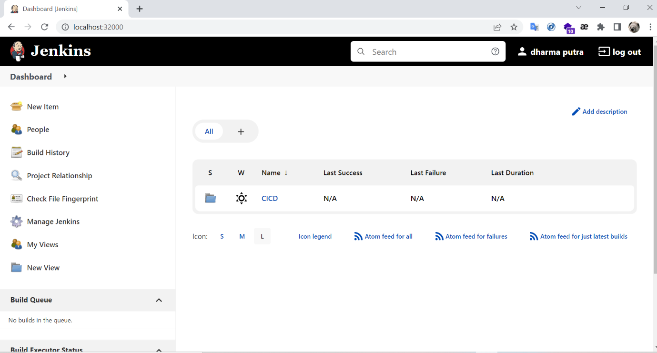

* Select job Jenkins to use deployment.

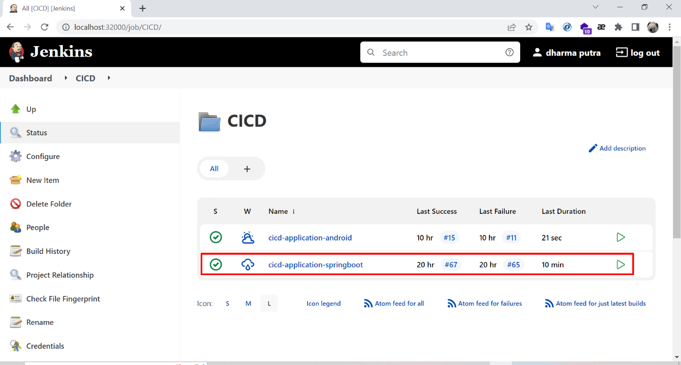

* Choice menu **“Build with parameters”**.

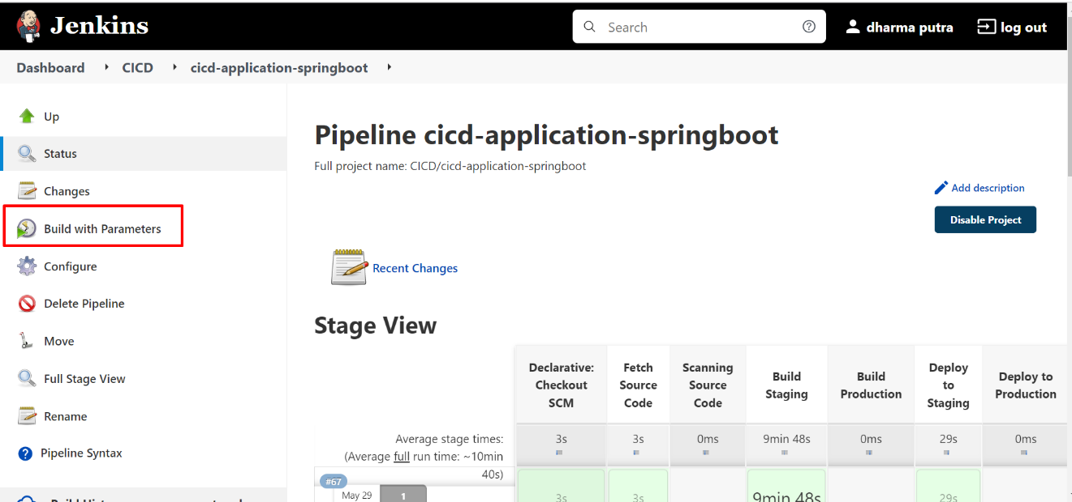

* Please input fields according to the environment and click build to next process.

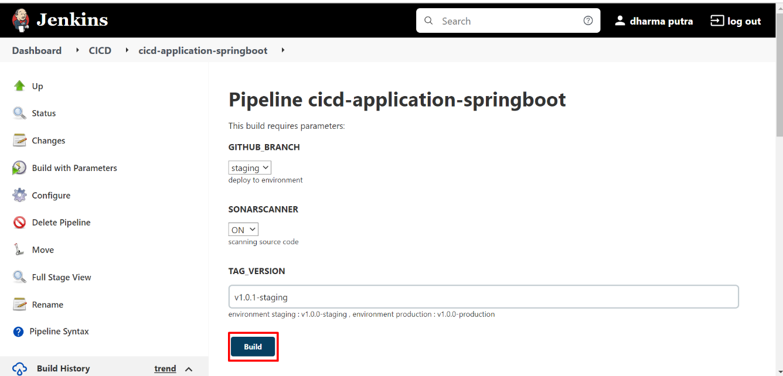

* Pipeline runs according to cicd flow design.

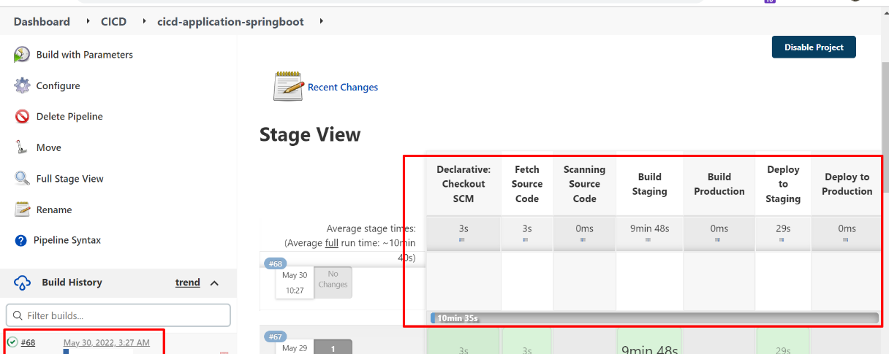

* Check job log in pipeline process (Scanning Source Code, Build, and Deploy), code review can check on sonarqube

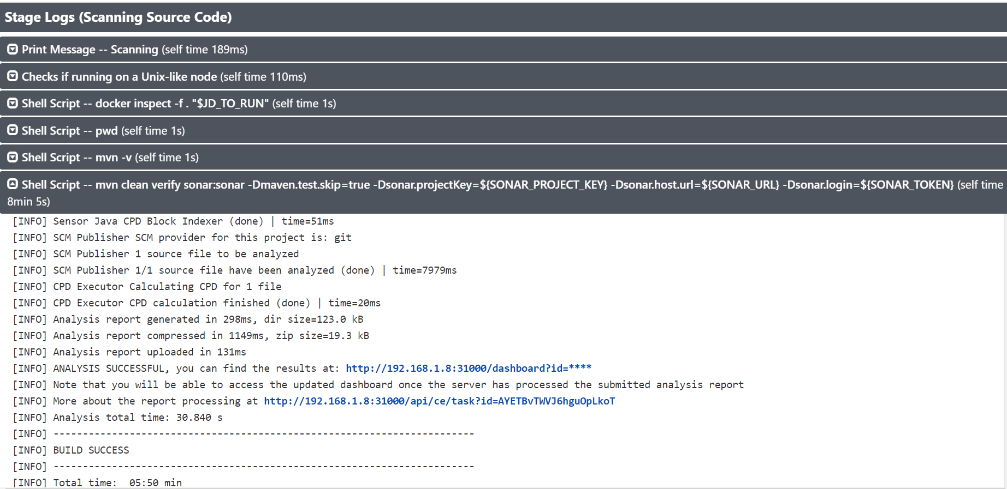

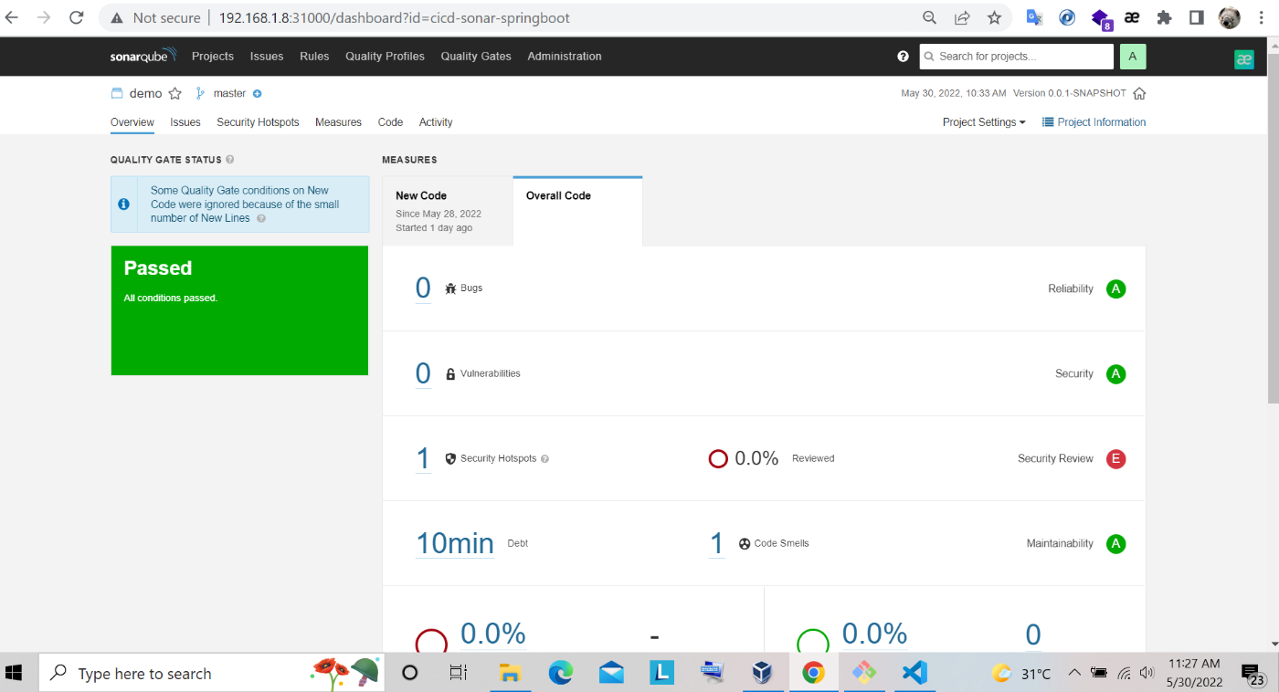

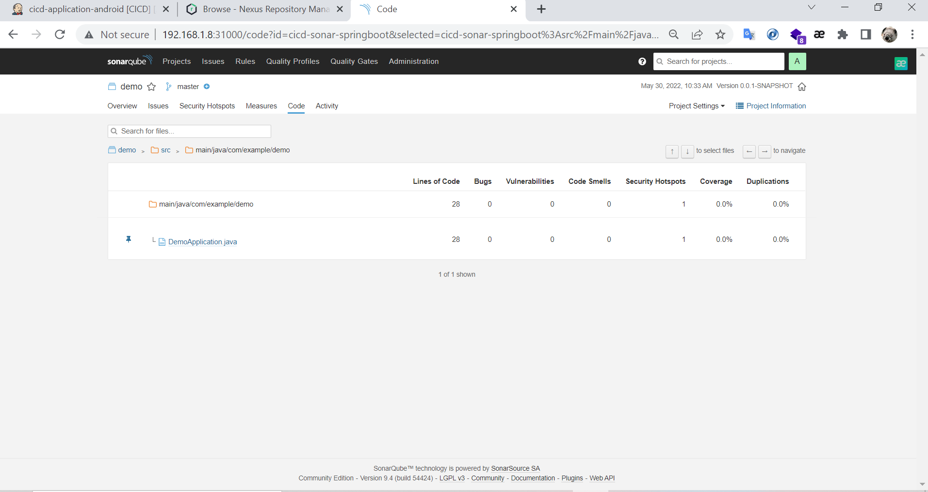

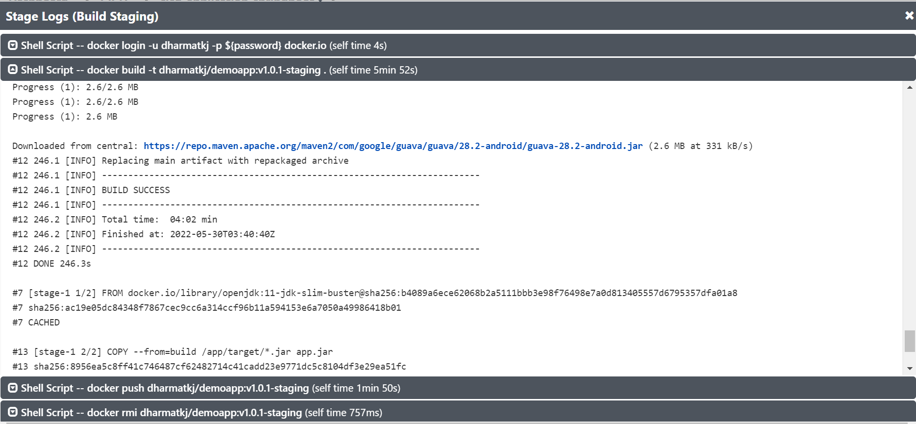

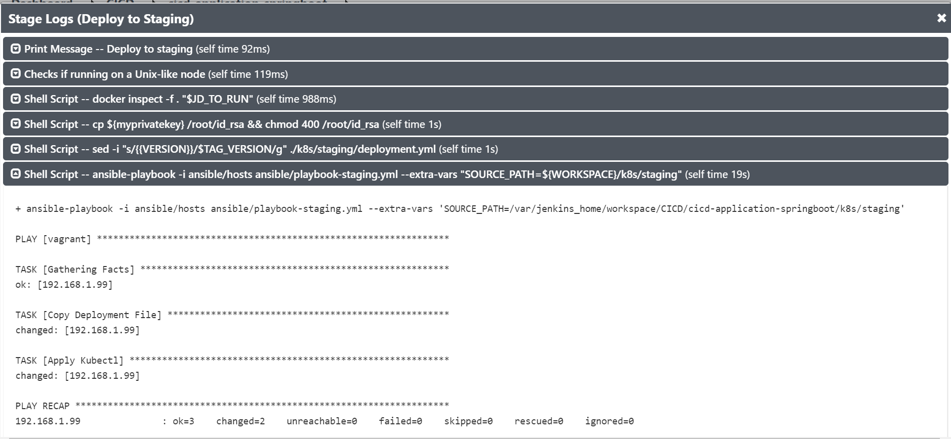

* Check status update service application on Kubernetes after deploy

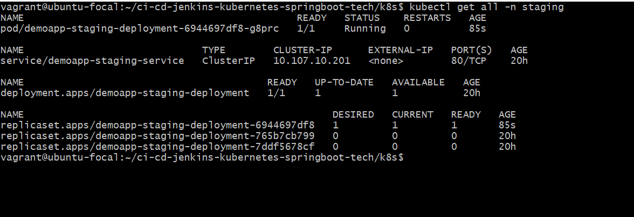

* Check deployment file application to make sure tag version image updated

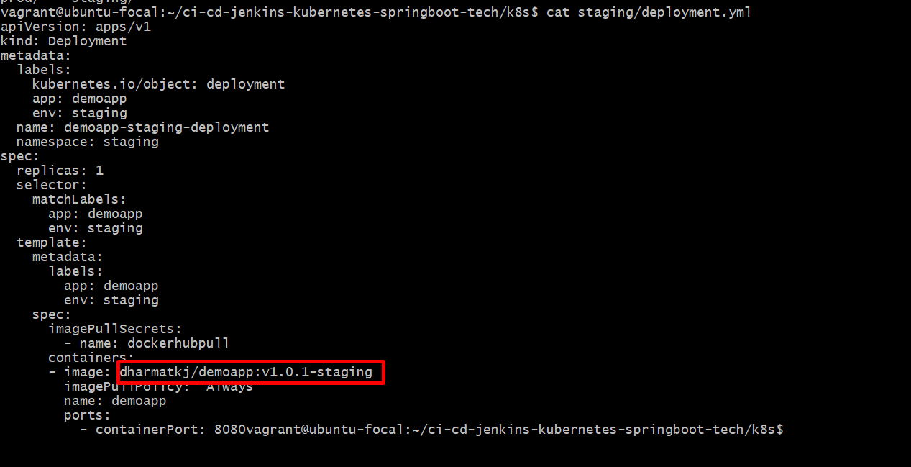

* Image already to store on docker hub registry

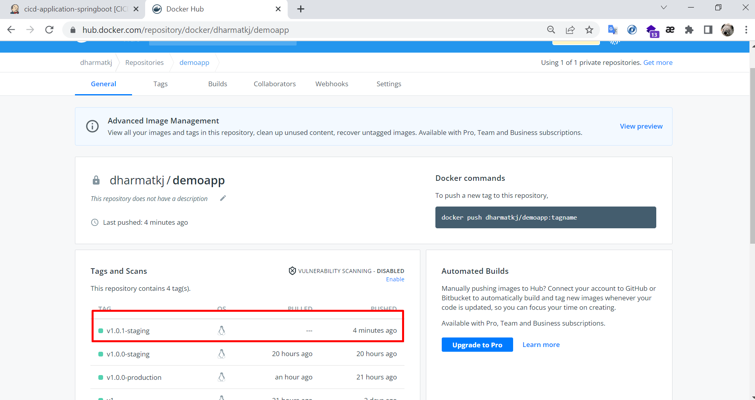

* Try access endpoint web application after deploy.

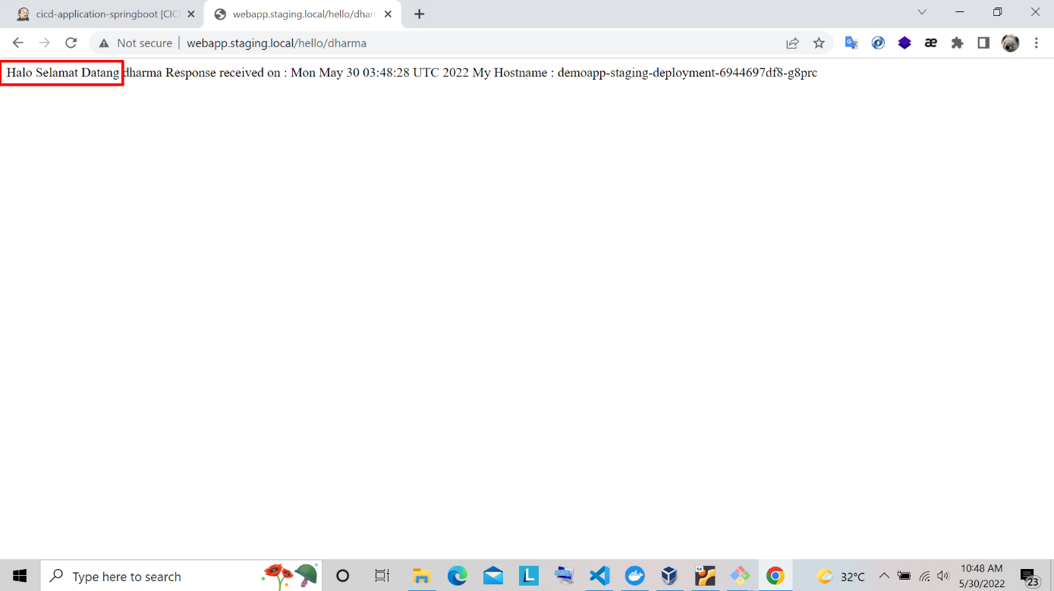

* **Run Jenkins to Deploy Web Applications Production Environment**
* After staging already update, next to deploy environment production. Check endpoint url make sure still not yet update.

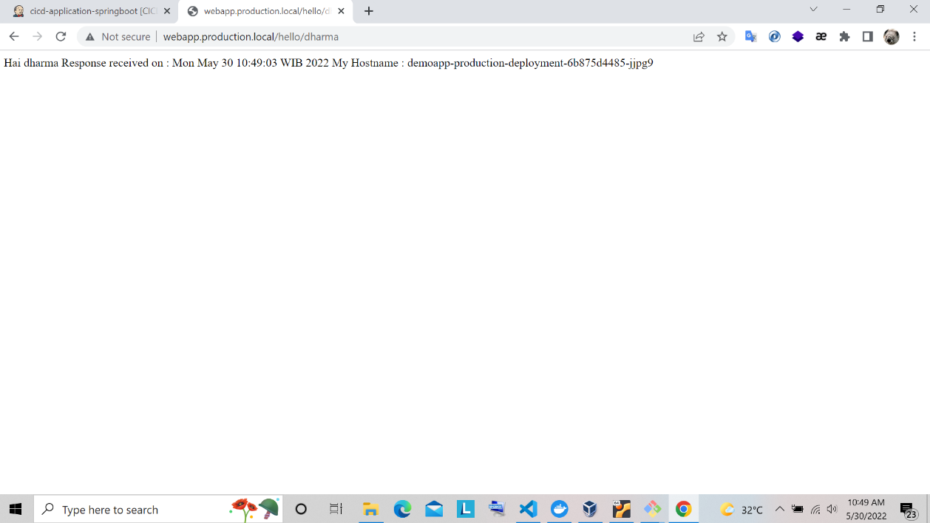

* Create merge request with branch after test on staging environment.

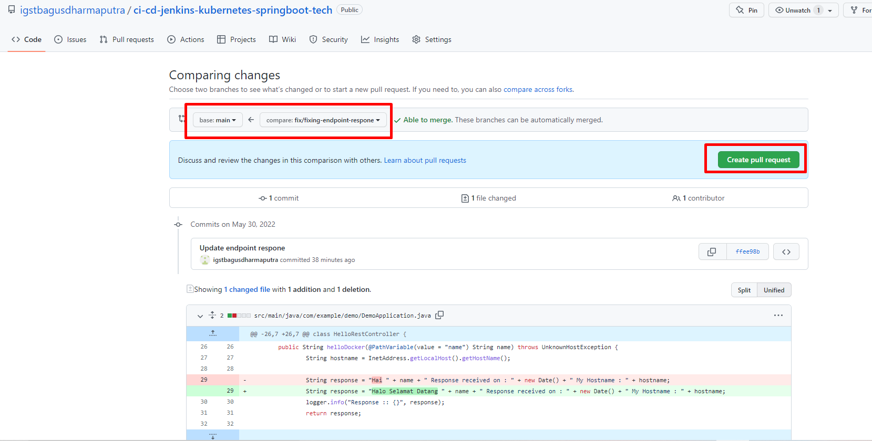

* Approve merge request.

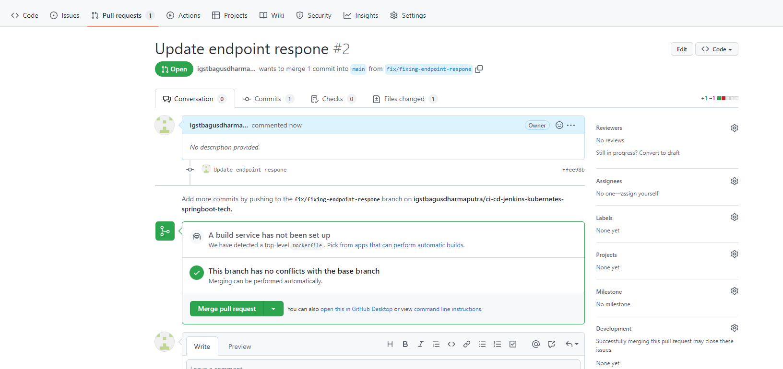

* Check file changes on branch **main** for environment production.

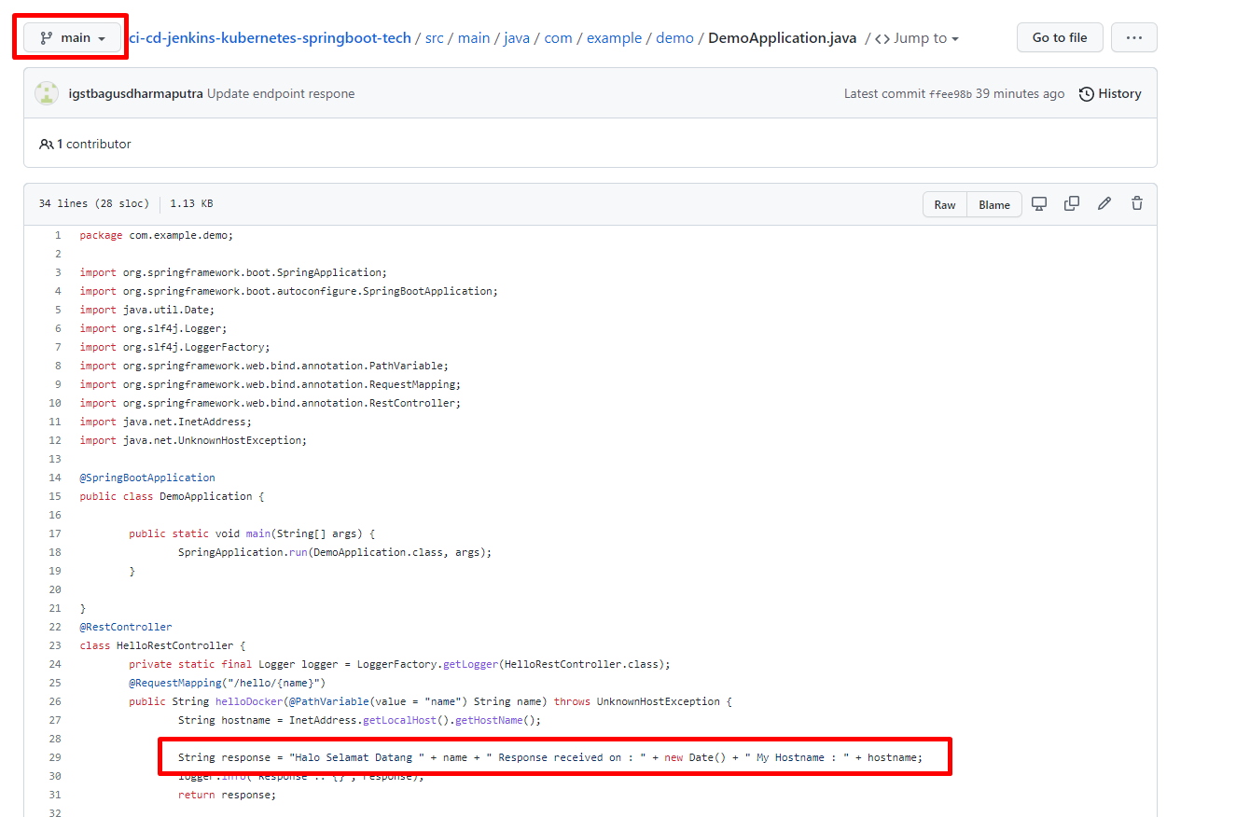

* Go to Jenkins with run pipeline and input fields to deploy production.

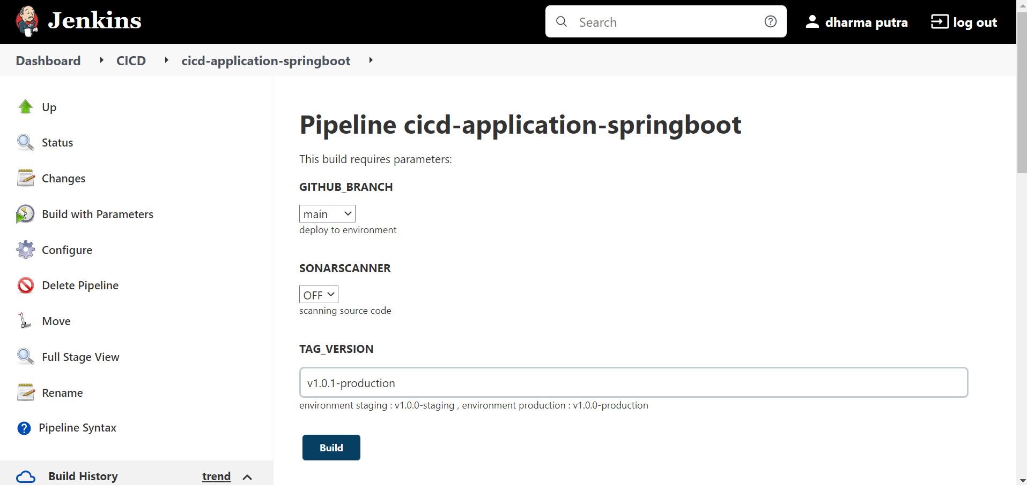

* Pipeline already to process jobs to update image applications and deploy.

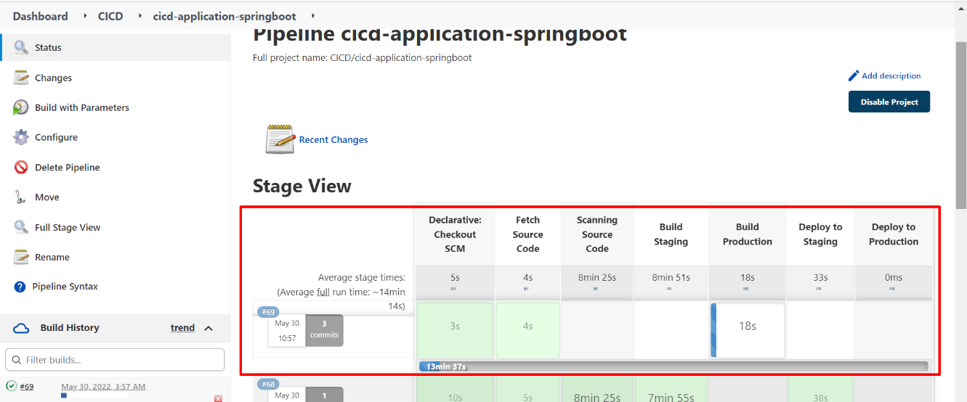

* Show log on job build

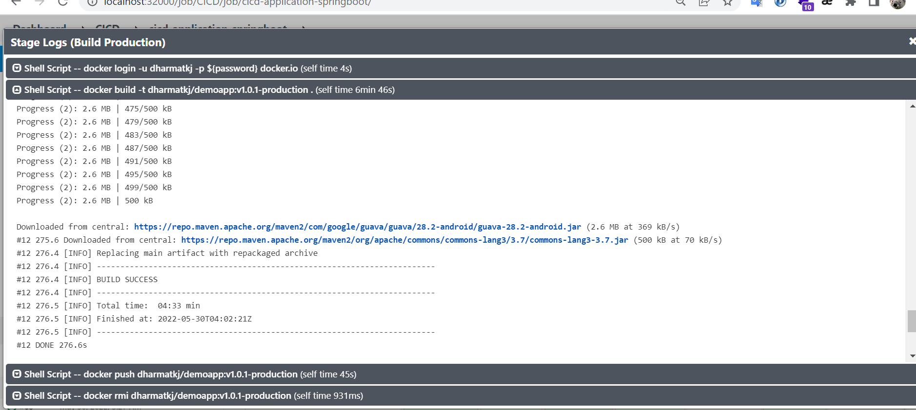

* Show logs deploy to make sure job success.

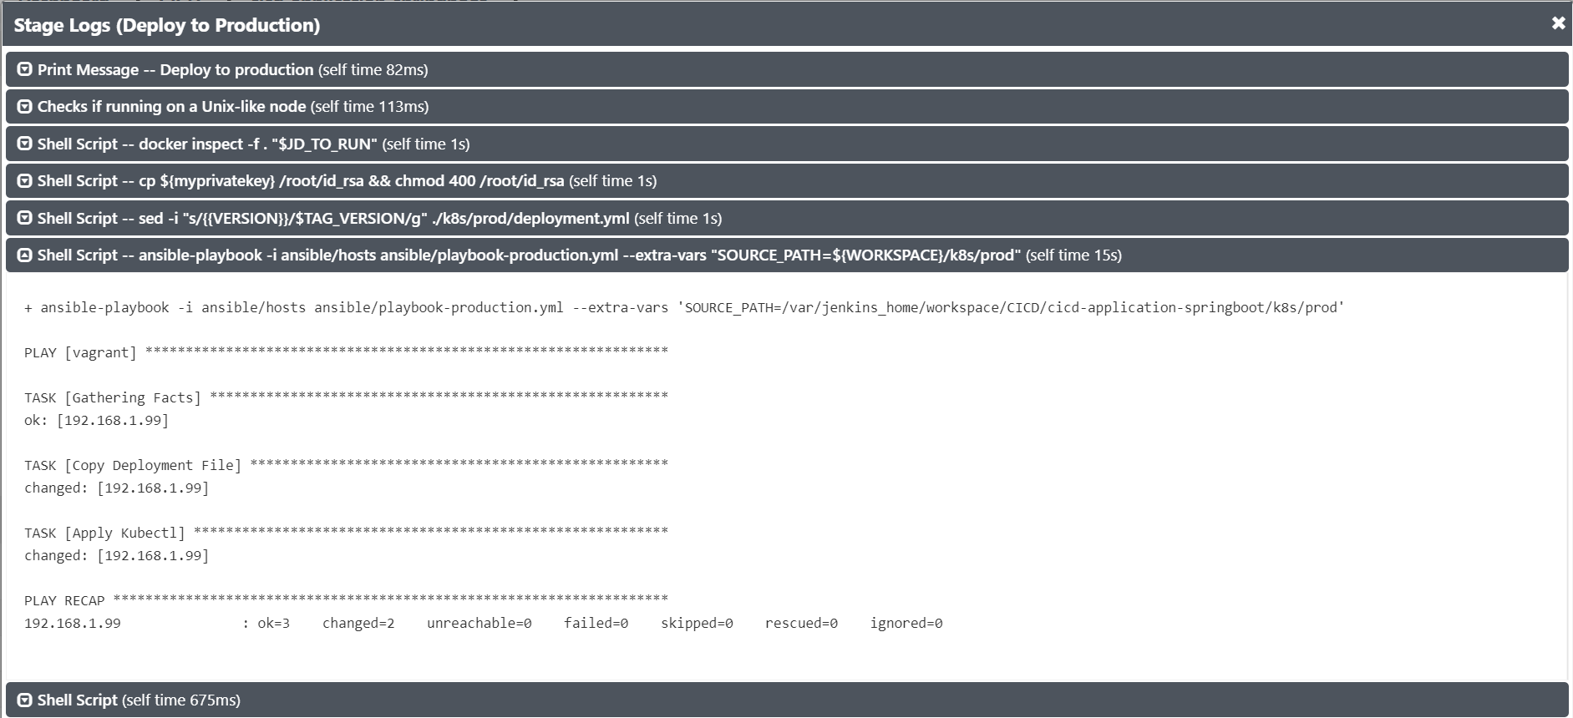

* Check service on Kubernetes after deployment update.

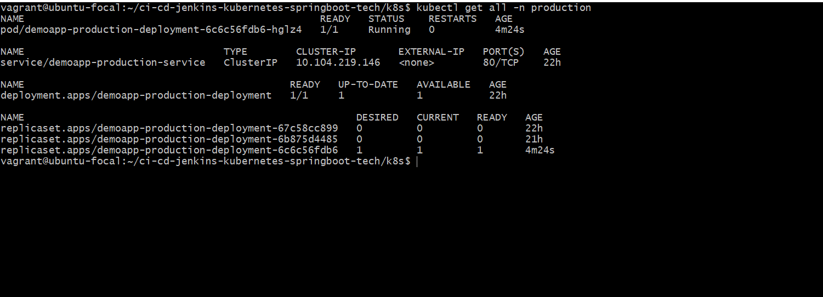

* Make sure to changes tag version image on deployment file.

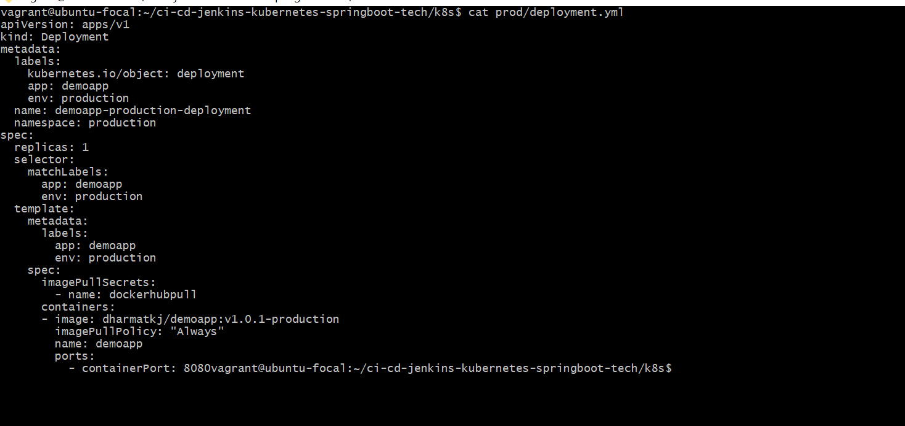

* Final result after deployment.

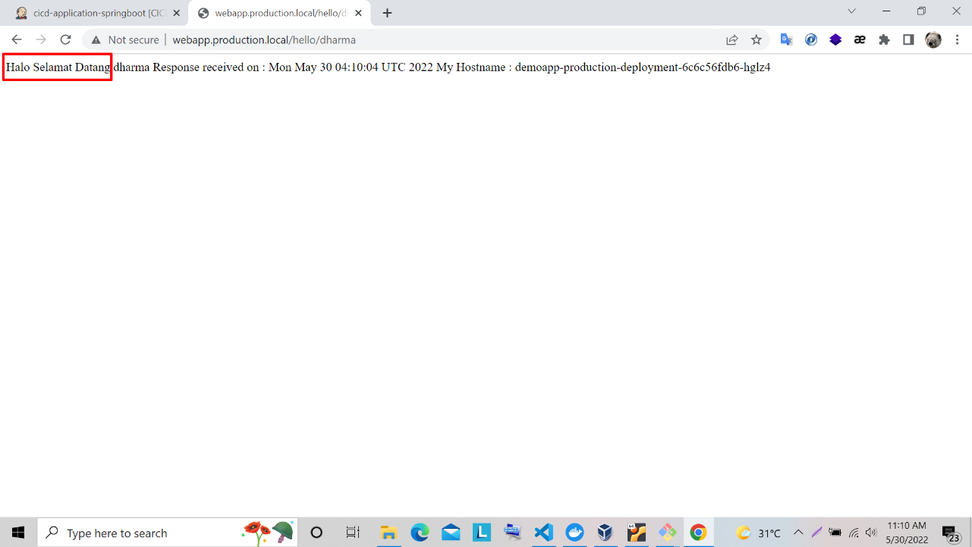

1. How to use CI/CD Android with Jenkins

* **Check status before update deployment application android**
* Please open application on your mobile phone.



* **Developer create branch and update page mobile**
* Go to your code editor and update source on new branch for deploy

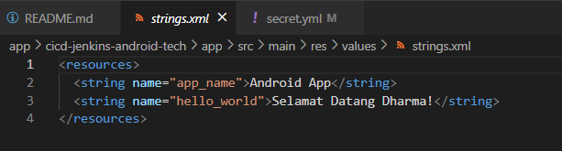

* Push branch to update on repository.

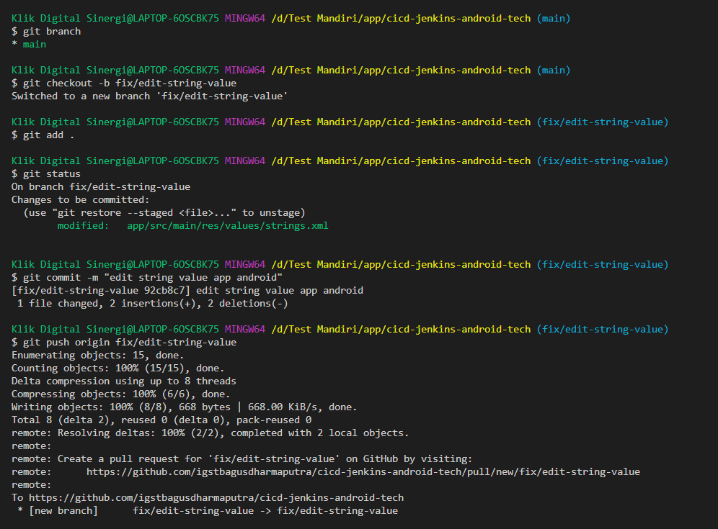

* Create pull request to update on branch **main** for deployment.

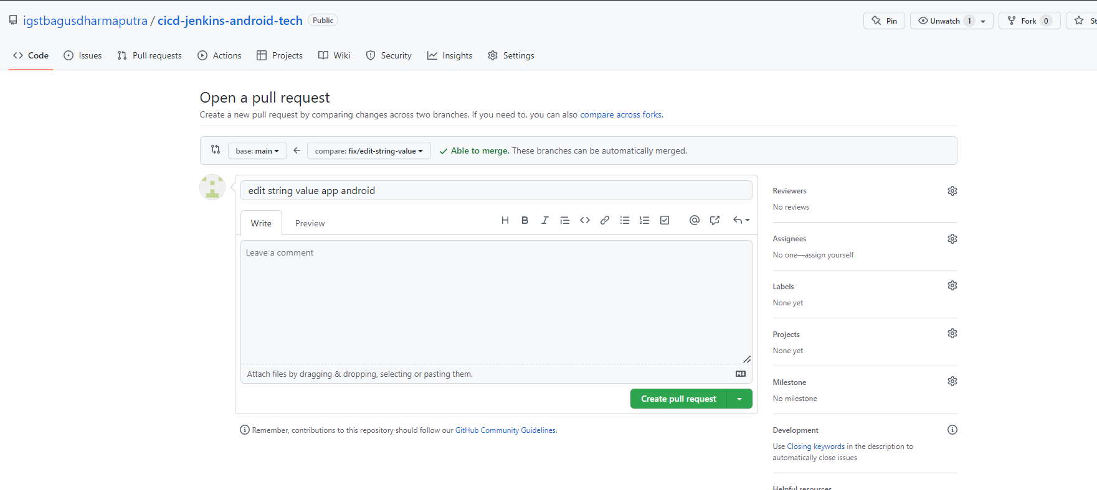

* Show changes code when pull request.

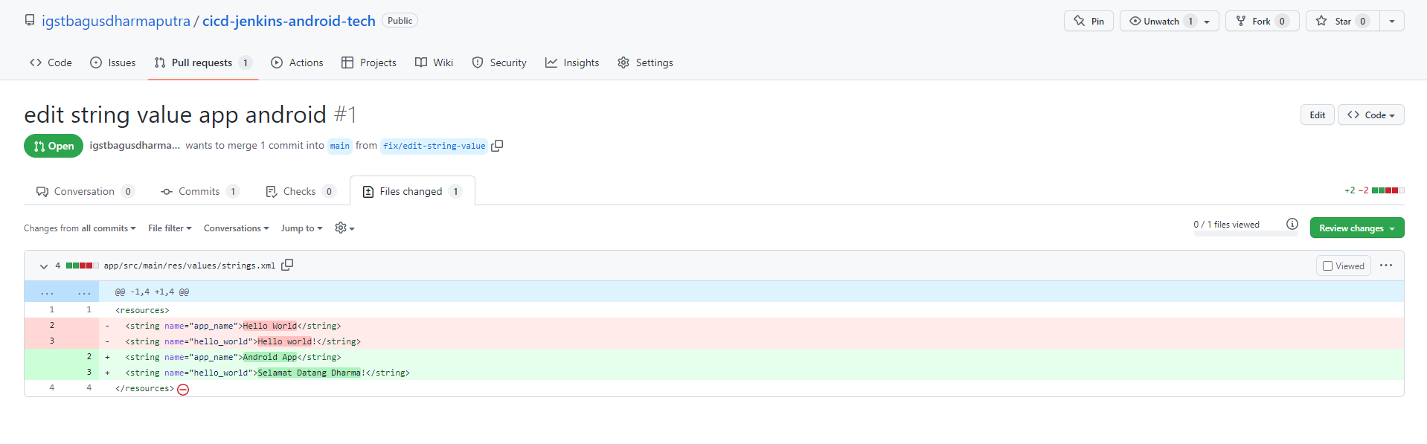

* Approve pull request to update on branch **main**.

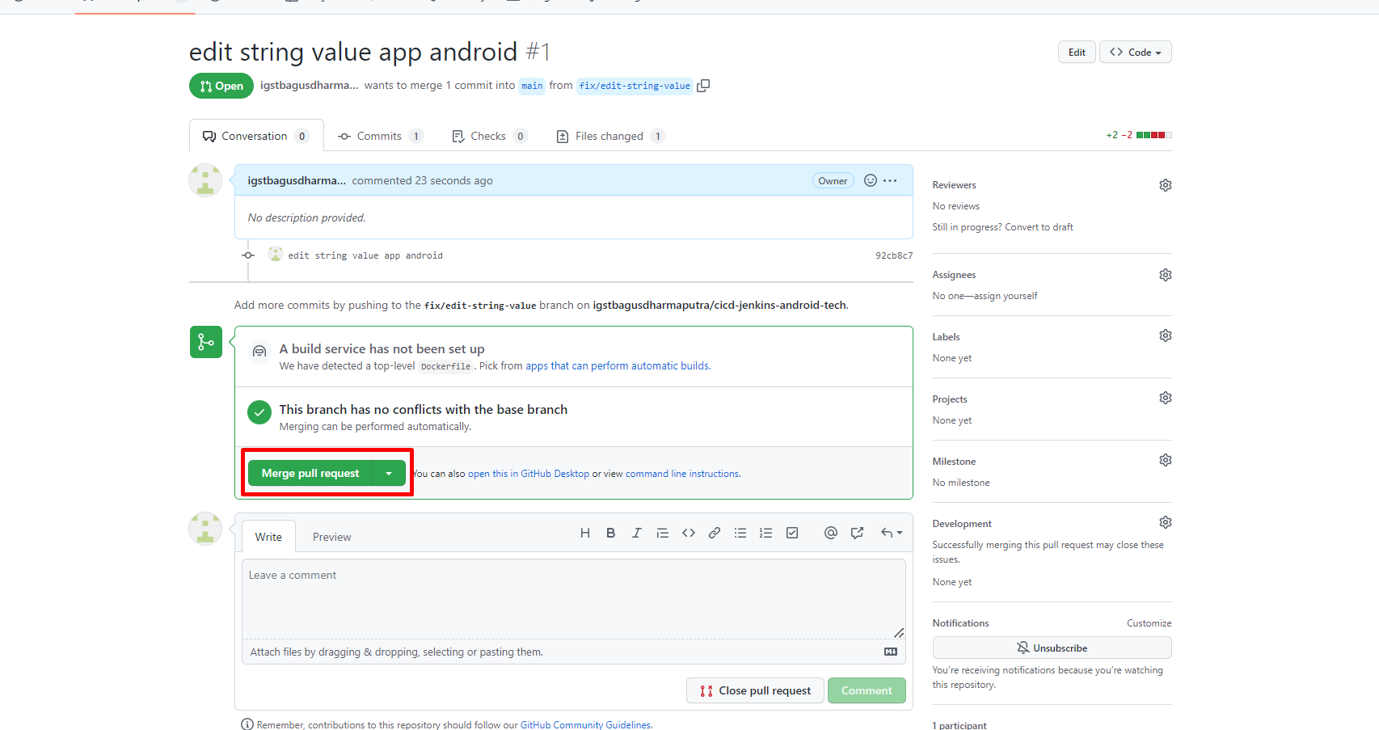

* Check changes code after pull request on branch **main**.

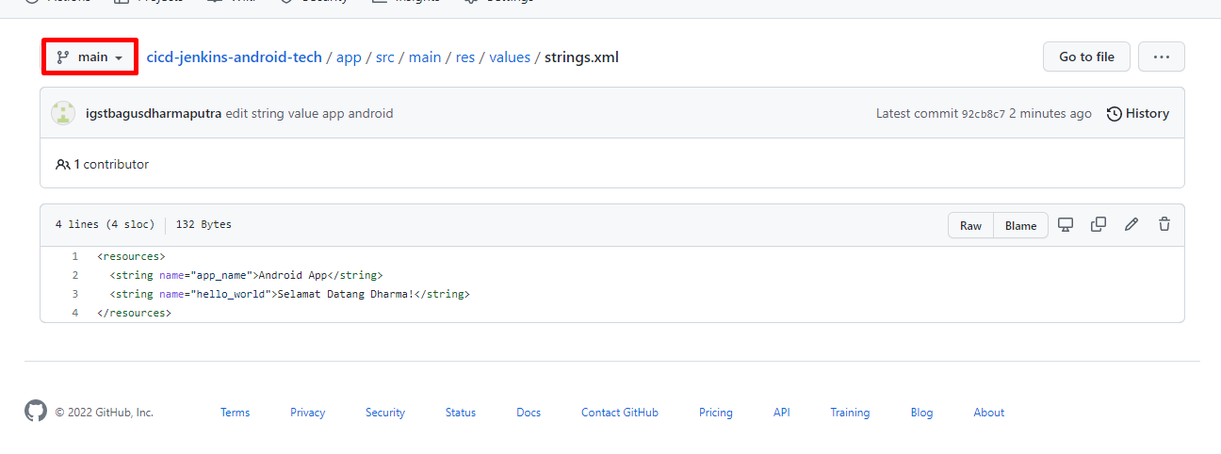

* Show artifactory application android before deploy.

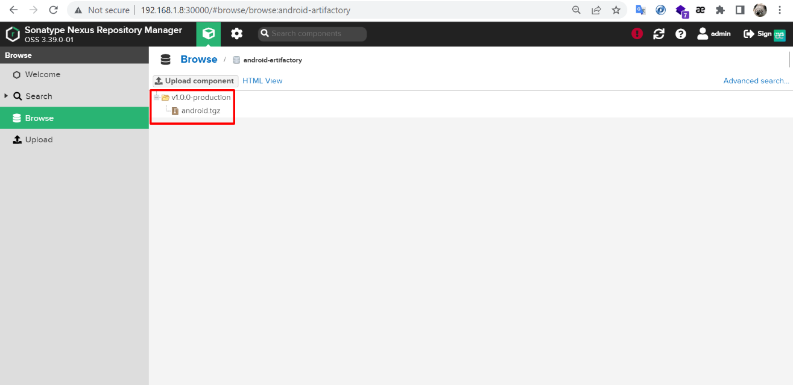

* **Run Jenkins to Deploy Application Mobile**
* Go to Jenkins and select job to use deployment application android.
* Input fields for running pipeline process.

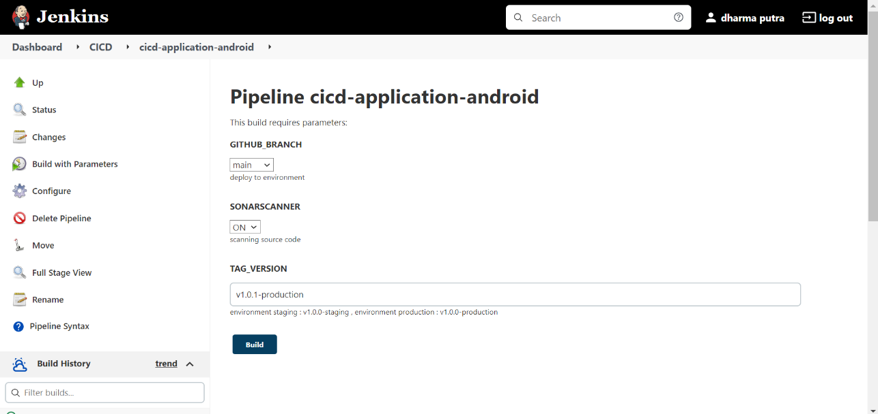

* Show log scanning for check code on sonarqube.

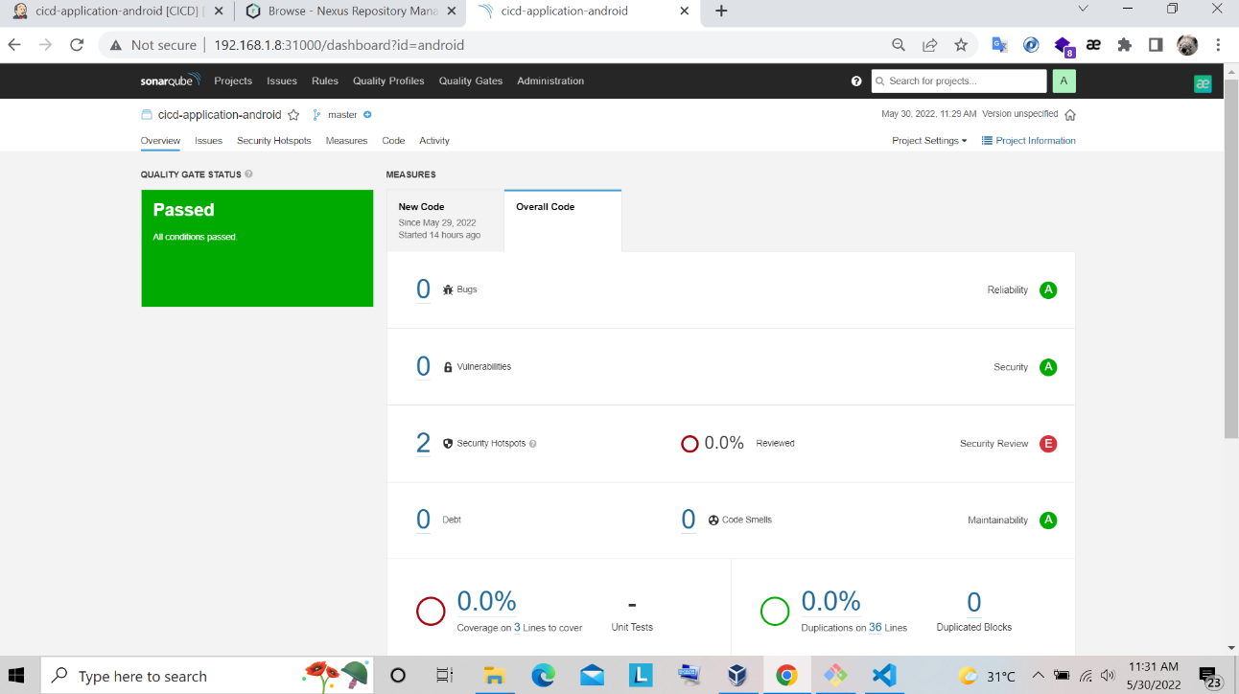

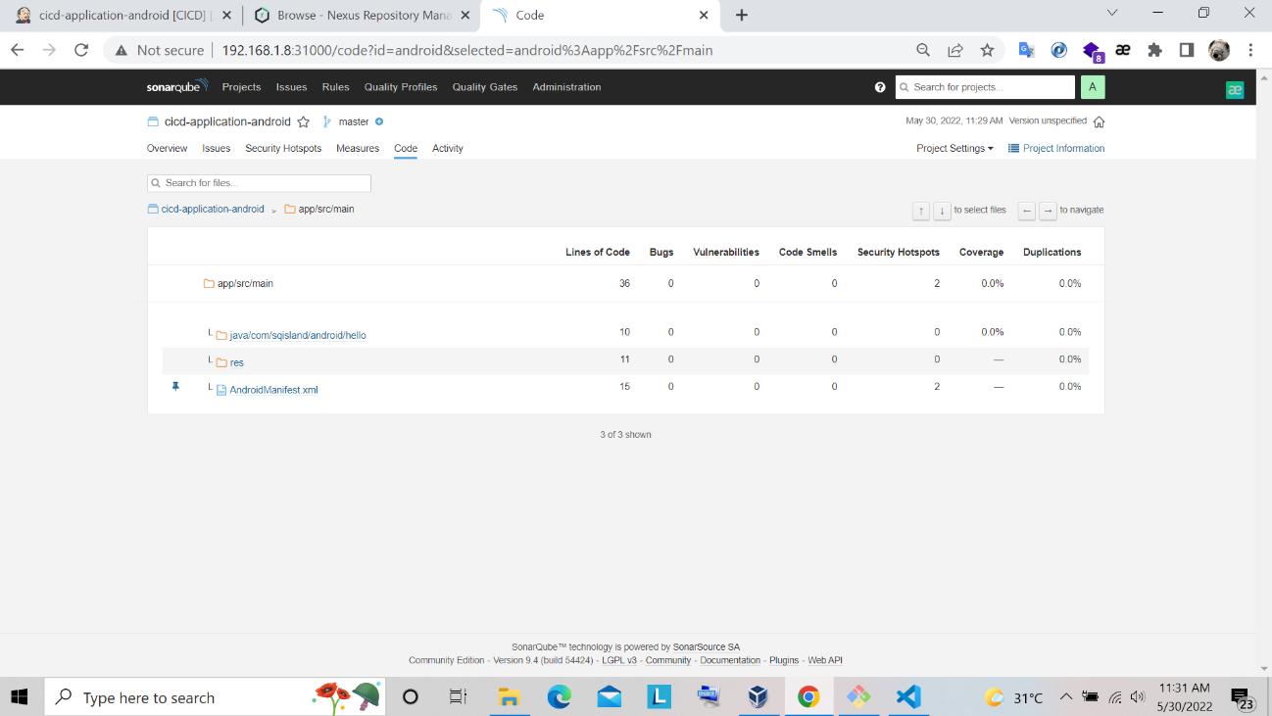

* Show log build to check process build success.

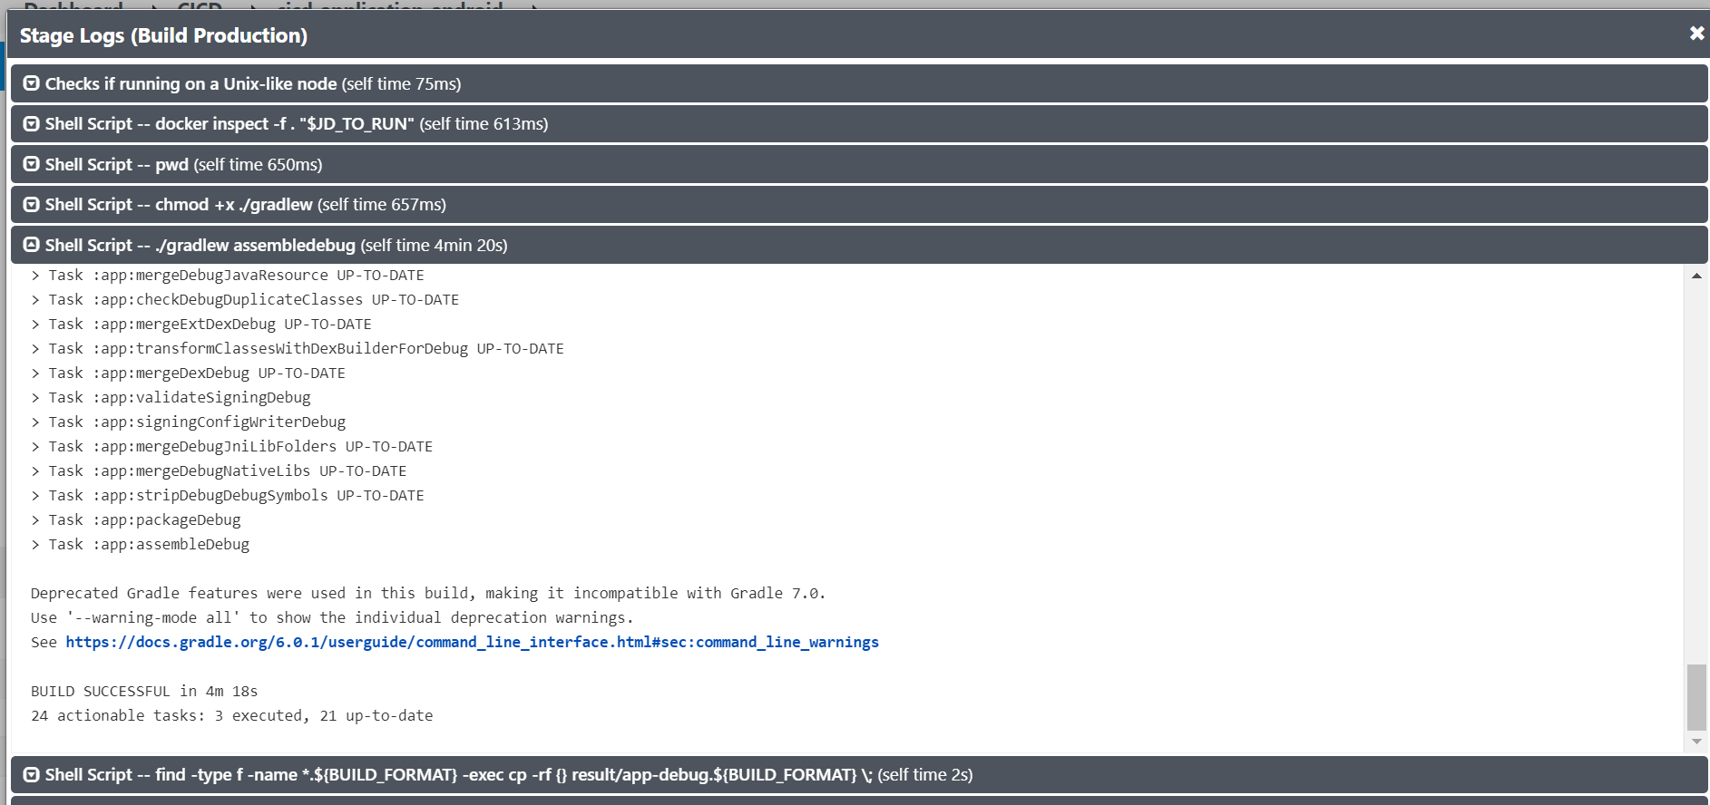

* Check log deploy to make sure artifact android store on nexus repository.

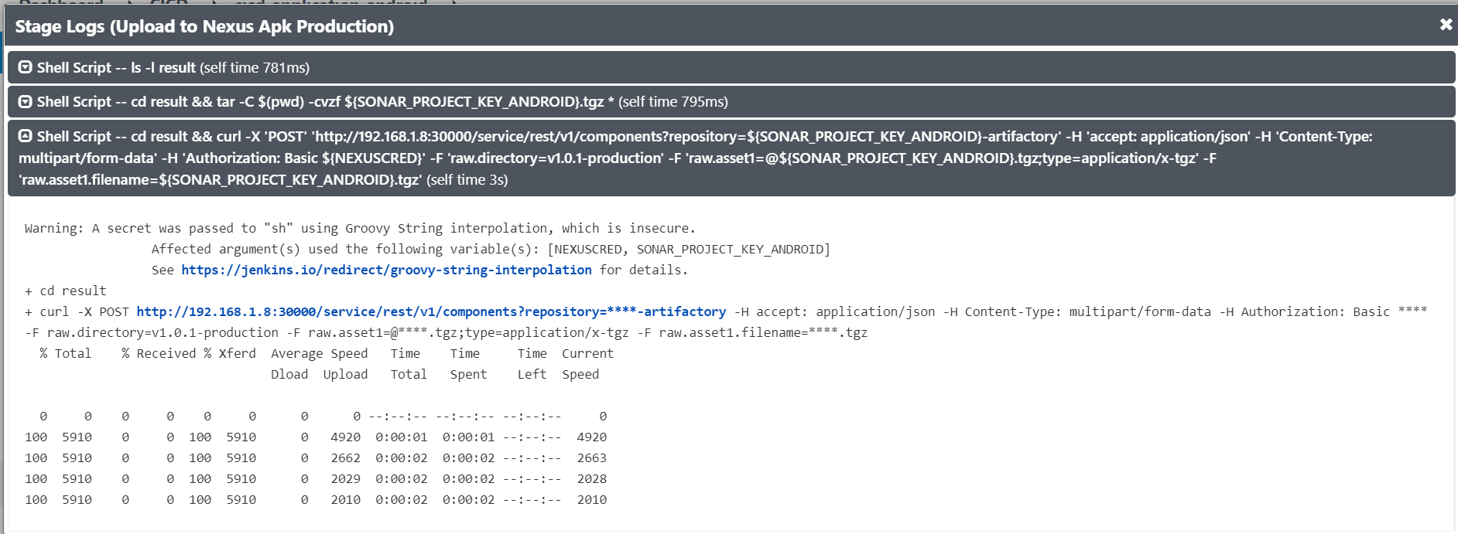

* Download artifact on nexus repository and install on your mobile phone.

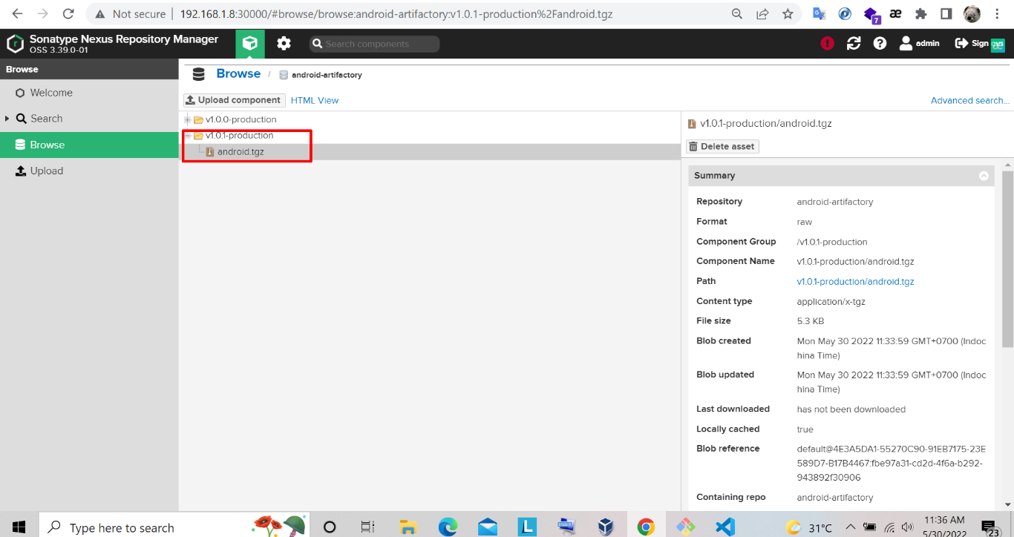

* Final result after install new mobile application

